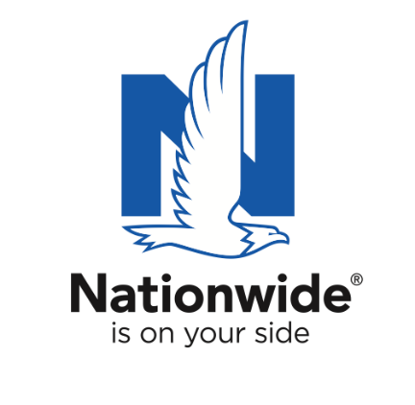
FOR IMMEDIATE RELEASE

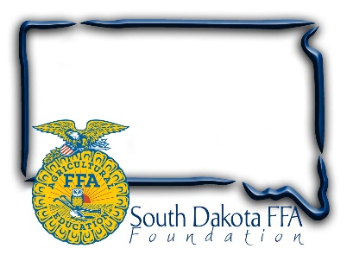
October 1, 2022

Contact:
Gerri Eide
SD FFA Foundation
gerri@sdffafoundation.org
605-765-4865

Nominate Local Teachers for SD’s Top
Agricultural Educator Award

Nationwide’s Golden Owl Award® recognizes extraordinary agricultural teachers in nine states and supplies funding to advance their programs

Bath, SD – Agricultural educators serve a critical role in their communities, devoting countless hours to prepare students for successful careers and help them pursue their passions. To honor their contributions and support them with additional resources, Nationwide and the SD FFA Foundation are accepting nominations for South Dakota’s leading agricultural teachers for a chance to be named as the 2022-2023 Ag Educator of the Year.

Nationwide and its state partners recently recognized 51 outstanding agricultural teachers as 2021-2022 Golden Owl Award® finalists and then honored seven grand prize winners as their state’s Ag Educator of the Year. Every finalist received $500 in funding to help future educational efforts and the grand prize winners received $3,000 and the coveted Golden Owl Award trophy.

As the number one insurer of farms and ranches in the U.S.¹, Nationwide inaugurated the Golden Owl Award in 2018 by recognizing the contributions of Iowa and Ohio agricultural teachers. As a result of the positive response from the communities in which Golden Owl Award nominees make a difference, the Golden Owl Award has since expanded to recognize outstanding educators across seven states: California, Illinois, Indiana, Iowa, New York, Ohio and Pennsylvania. Now in 2022-2023, the award is expanding again to include Nebraska and South Dakota.

Nominate any South Dakota agriculture educator for the 2022-2023 Golden Owl Award now October 1st through Dec 31 at https://bit.ly/SDGoldenOwl.

“The Golden Owl Award seeks to thank agricultural teachers for the extraordinary care they bring to their work as they go above and beyond in educating America’s youth and future leaders,” said Brad Liggett, Nationwide’s president of Agribusiness. “We encourage students, parents, fellow teachers and others to nominate their favorite agricultural teachers to acknowledge their hard work.”

Following the nomination period, closing December 31, a selection committee will evaluate nominations and select 7 finalists in SD who will receive an individualized plaque and $500. One finalist will then be chosen as the grand prize winner, earning the 2022-2023 Ag Educator of the Year title for SD and receiving the coveted Golden Owl Award trophy and $3,000 to help fund future educational efforts.
Nationwide supports the future of the ag community through meaningful sponsorships of national and local organizations. In conjunction with the Golden Owl Award, Nationwide is donating $5,000 to each participating state’s FFA, including SD, to further support the personal and professional growth of students, teachers and advisors alike.

The Golden Owl Award is the result of partnerships between Nationwide, the SD FFA Foundation, California FFA, California Farm Bureau, Illinois FFA, Illinois Association of Vocational Agriculture Teachers, Farm Credit Illinois, Indiana FFA, Farm Credit Mid-America, the Iowa FFA Foundation, New York FFA, New York Farm Bureau, Ohio FFA, Ohio Farm Bureau, AgCredit, Pennsylvania FFA, Pennsylvania Farm Bureau, Compeer Financial, Nebraska FFA Foundation and Nebraska Agricultural Educators Association.

To nominate a teacher or learn more about the Golden Owl Award, visit GoldenOwlAward.com.

About Nationwide
Nationwide, a Fortune 100 company based in Columbus, Ohio, is one of the largest and strongest diversified insurance and financial services organizations in the United States. Nationwide is rated A+ by both A.M. Best and Standard & Poor’s. An industry leader in driving customer-focused innovation, Nationwide provides a full range of insurance and financial services products including auto, business, homeowners, farm and life insurance; public and private sector retirement plans, annuities, mutual funds and EFTs; excess & surplus, specialty and surety; and pet, motorcycle and boat insurance. For more information, visit www.nationwide.com. Follow the firm on Facebook and Twitter.

Nationwide, Nationwide is on your side and the Nationwide N and Eagle are service marks of Nationwide Mutual Insurance Company. © 2022

